SafeRide+ Women: Your Guardian To Go
In propose work implementing web based SafeRide+ application for women safe ride during anytime. This app allow user to book ride or cancel ride and then can pay as per travel miles, user can authenticate driver via OTP approved ride and can send alert to registered email id (for SMS and whatsapp we need to purchase provider so we are sending alert to registered email id).
To implement this project we have designed following modules
- Driver Sign up: interested driver can sign up with the application
- Driver Login: driver can login to application
- Driver Location: using this module driver will post his location as laptop don’t have GPS so driver will enter manual latitude and longitude and if any user initiate request within 3 miles distance then driver will get notification and can accept and complete ride.
- Start Ride: after picking passenger driver will run this module to start ride
- Ride Complete: after completing ride driver will run this module to collect payment based on miles travelled
- Passenger Sign up: passenger or user can sign up with the application
- Passenger Login: passenger can login to system
- Book Ride: using this module user will enter his location details and then can get list of drivers in 3 miles distance and then can send ride request. After ride request user will get OTP to authenticate or approved ride driver
- Cancel Ride: before start ride can cancel ride
- Raise Alert: this module will run to send user current location and driver details to passenger keen email
- View Past Rides: can able to view all past rides
- Feedback: can give feedback and ratings to drivers
Note: you need to run driver and passenger in separate tab so passenger can send request from one browser tab and driver can receive and accept ride notification from other tab
SCREEN SHOTS
To run project install python 3.7 and then install all packages given in requirements.txt file and then install MYSQL and then copy content from ‘database.txt’ file and paste in MYSQL console to create database.

Step 1: Now double click on ‘runServer.bat’ file to start python server and then will get below page
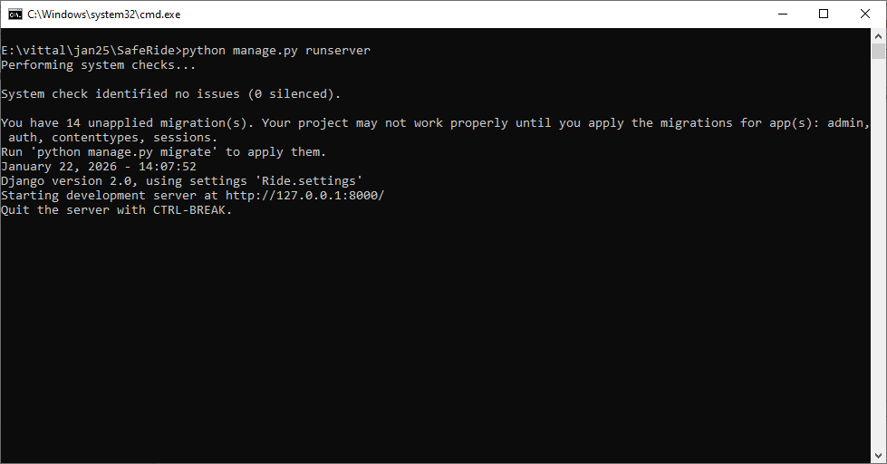
In above screen python server started and

Steps 2: now open browser and enter URL as http://127.0.0.1:8000/index.html and then press enter key to get below page
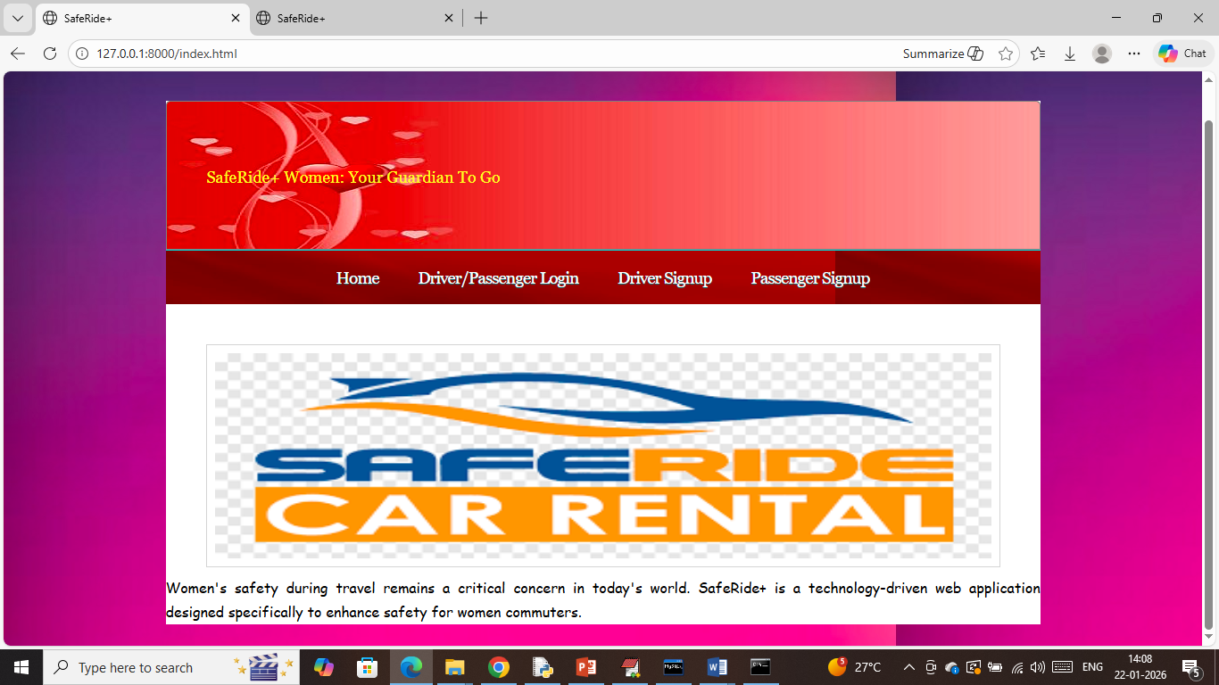
Step 3: In above screen click on ‘Driver Sign up’ link to get below page
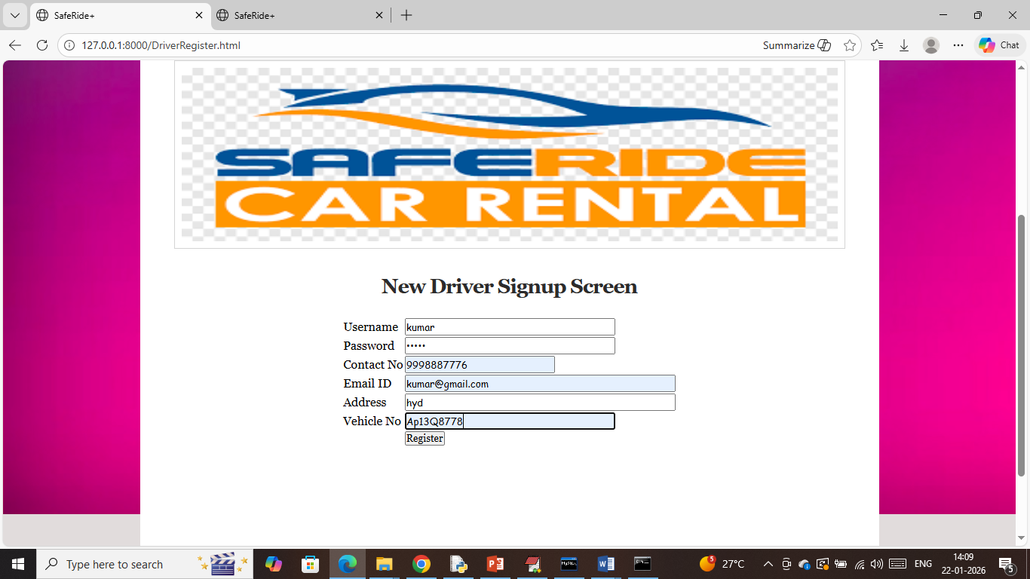
In above screen driver entering sign up details and then press button to get below page
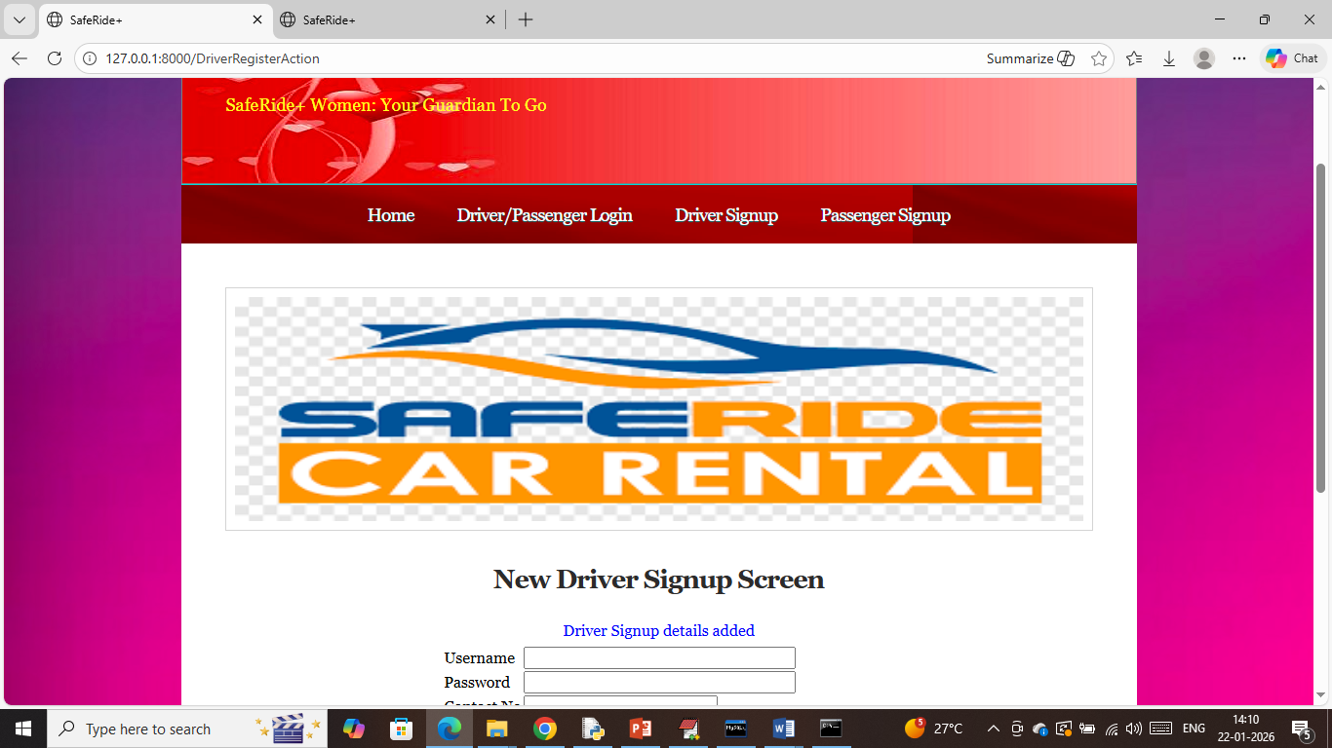
In above screen in blue text can see driver sign up completed and now click on ‘Passenger Sign up’ link to get below page.
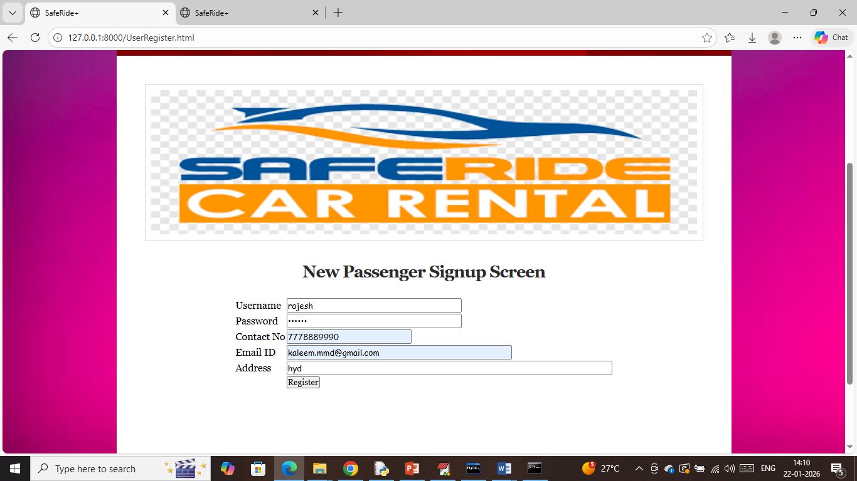
In above screen passenger entering sign up details along with valid email id to send alerts and then press button to get below page
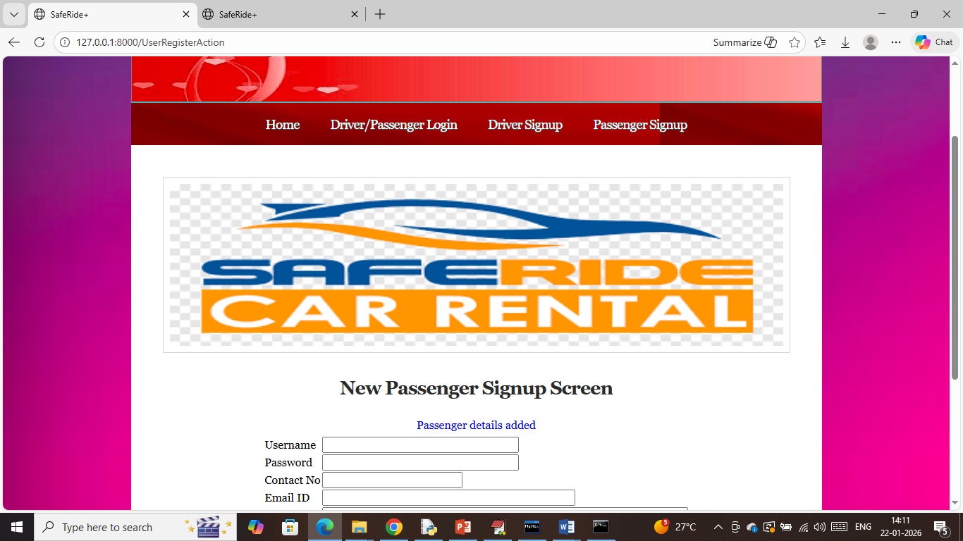
In above screen passenger sign up completed and now click on ‘Login’ link to login as driver
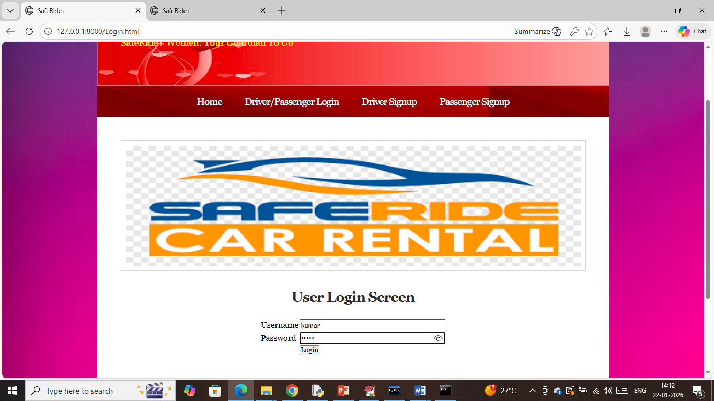
In above screen driver is login in one browser tab and then press button to get below page
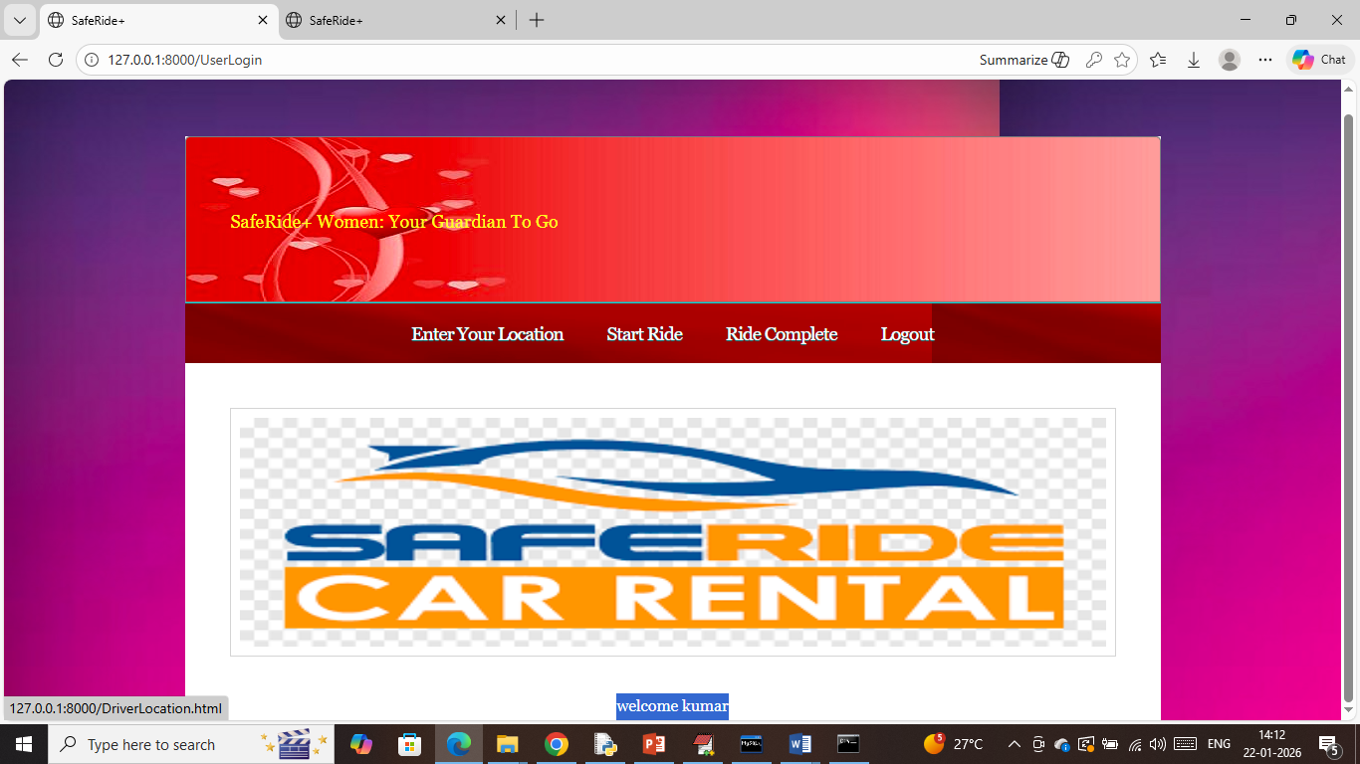
In above screen driver can click on ‘Enter Your Location’ link to post his location and to get ride request
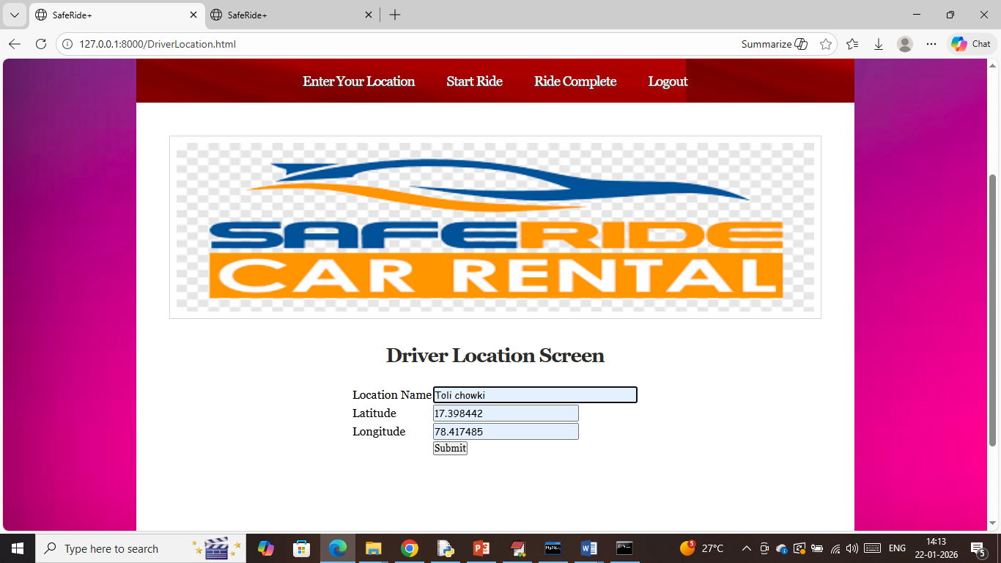
In above screen driver entering is location and then press button to get below page
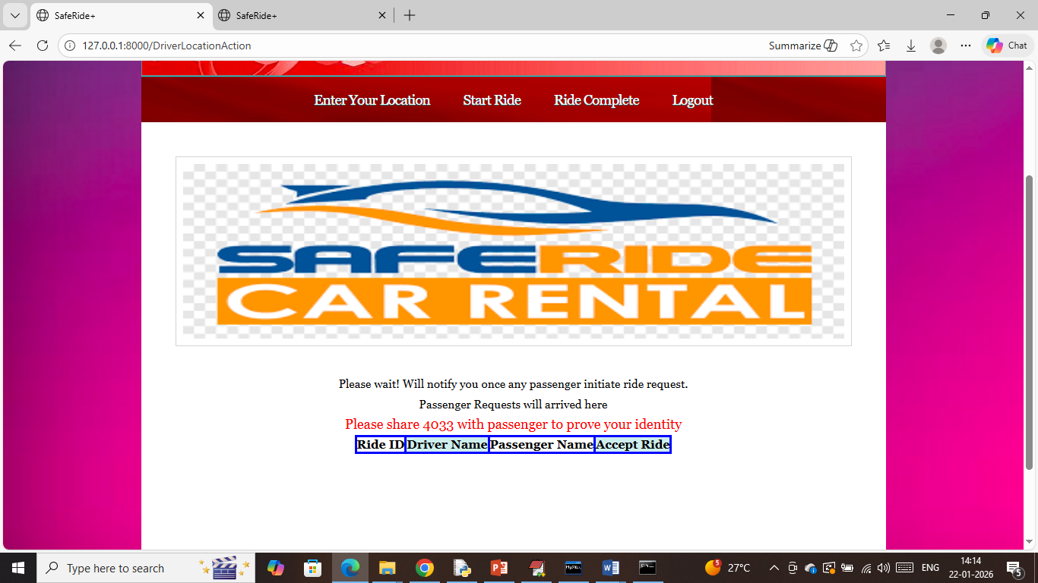
In above screen can see driver details sharing with passengers and upon receiving ride request will get notify in above table and this driver need to share above OTP to approved ride. Now open another tab and login as passenger to send ride request
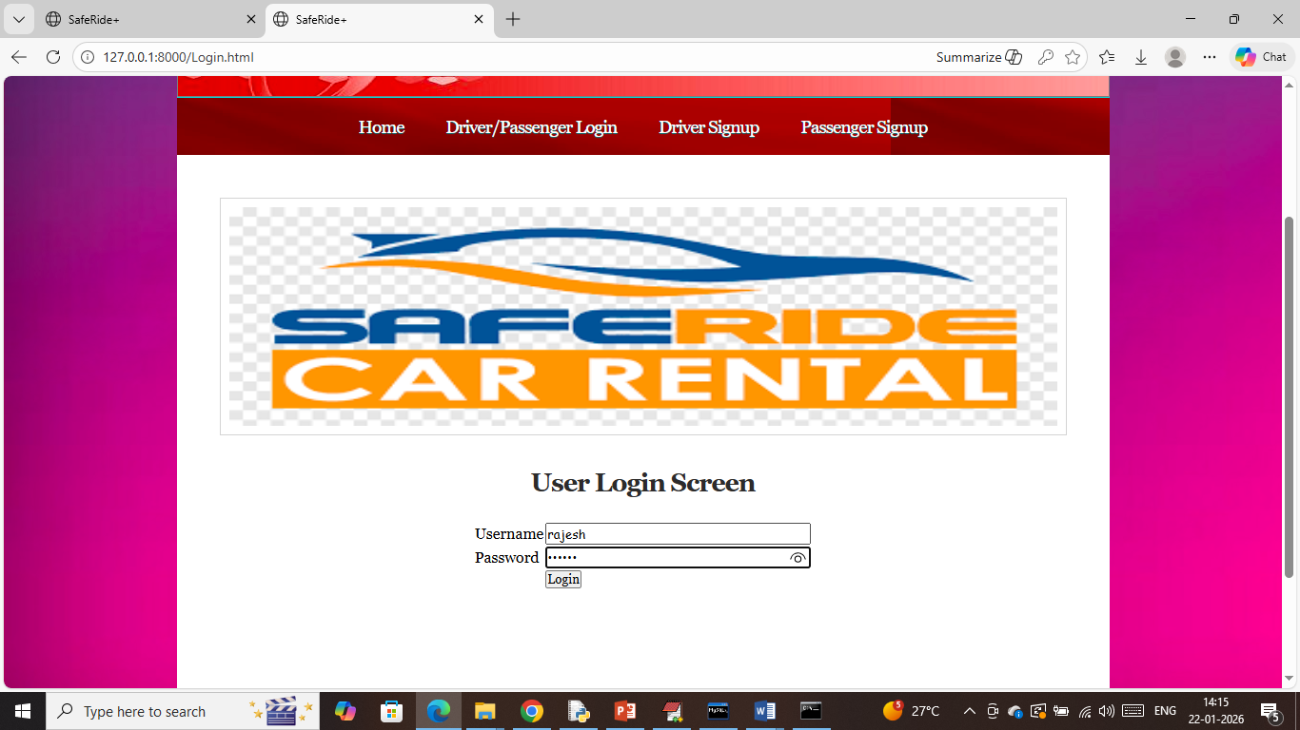
In above screen passenger is login and after login will get below page
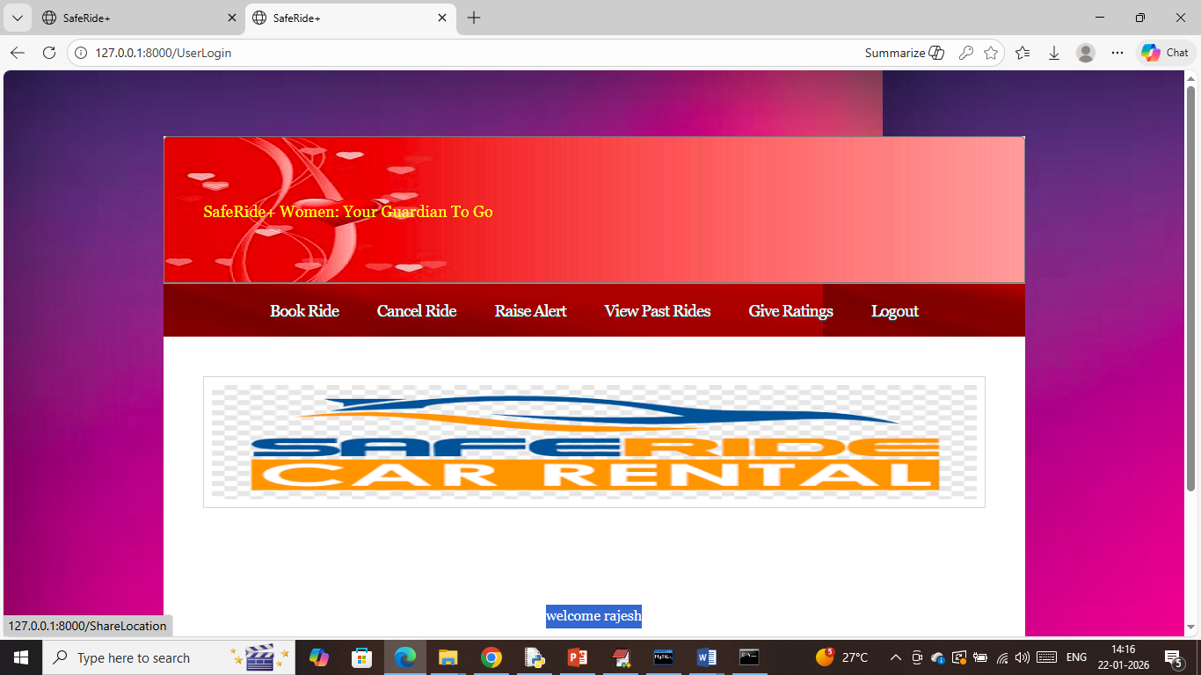
In above screen passenger can click on ‘Book Ride’ link to initiate ride request
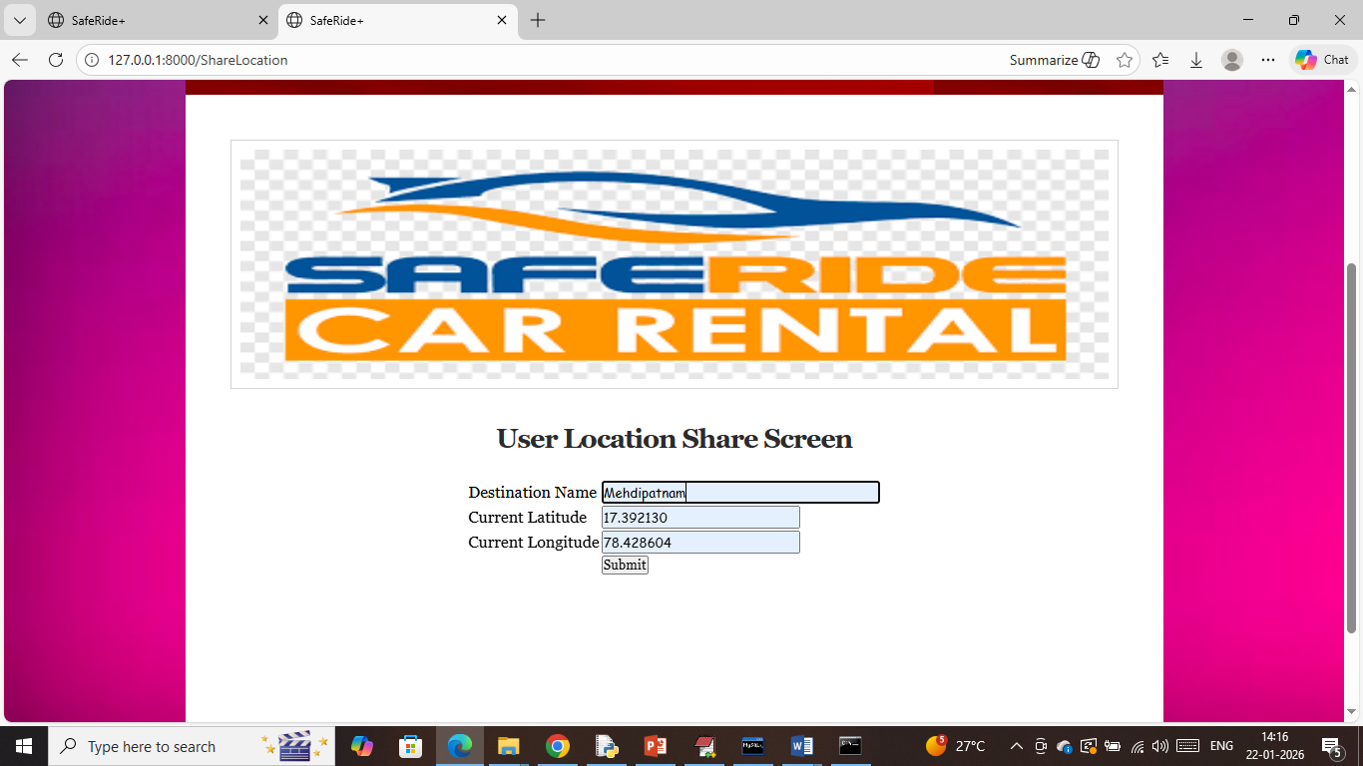
In above screen user will enter current latitude, longitude along with destination and then press button to get list of nearby drivers
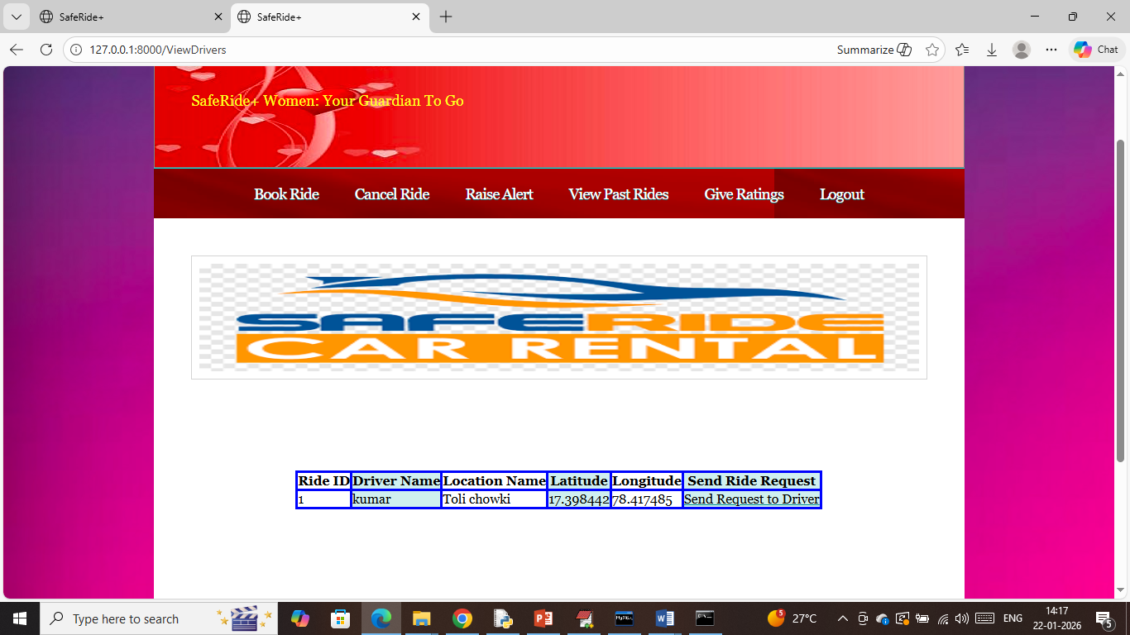
In above screen passenger got one driver details and can click on ‘Send Request to Ride’ link to send notification to driver and then will get below page
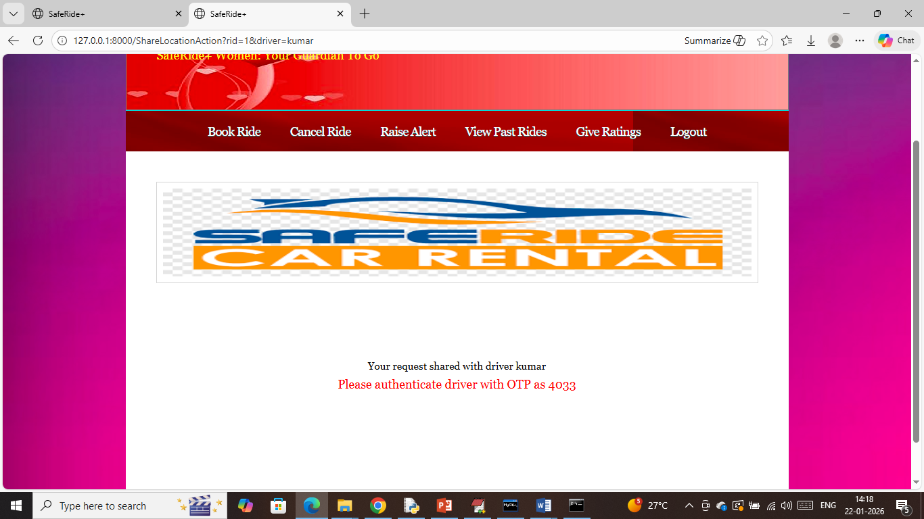
In above screen passenger got OTP which will get approved with driver and if driver say same OTP then only ride will be approved. Now in driver tab will get below notification
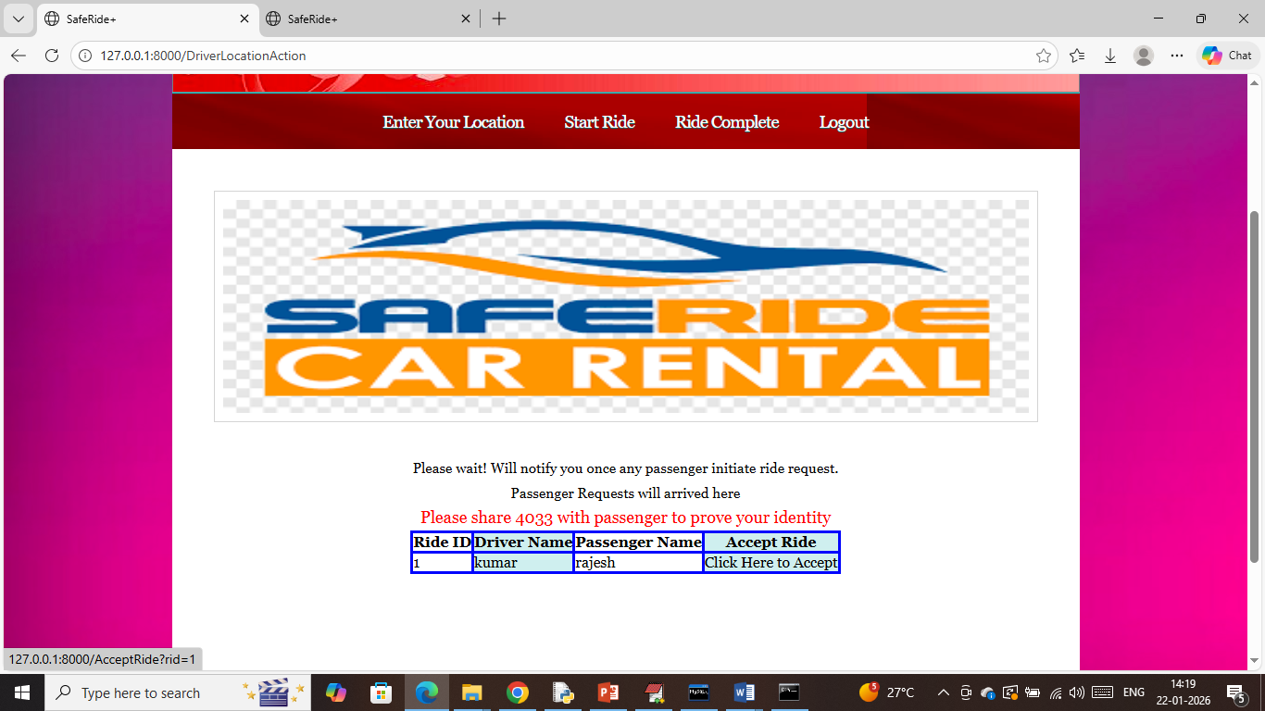
In above screen driver got notification and now click on ‘Click Here to Accept’ link to accept ride
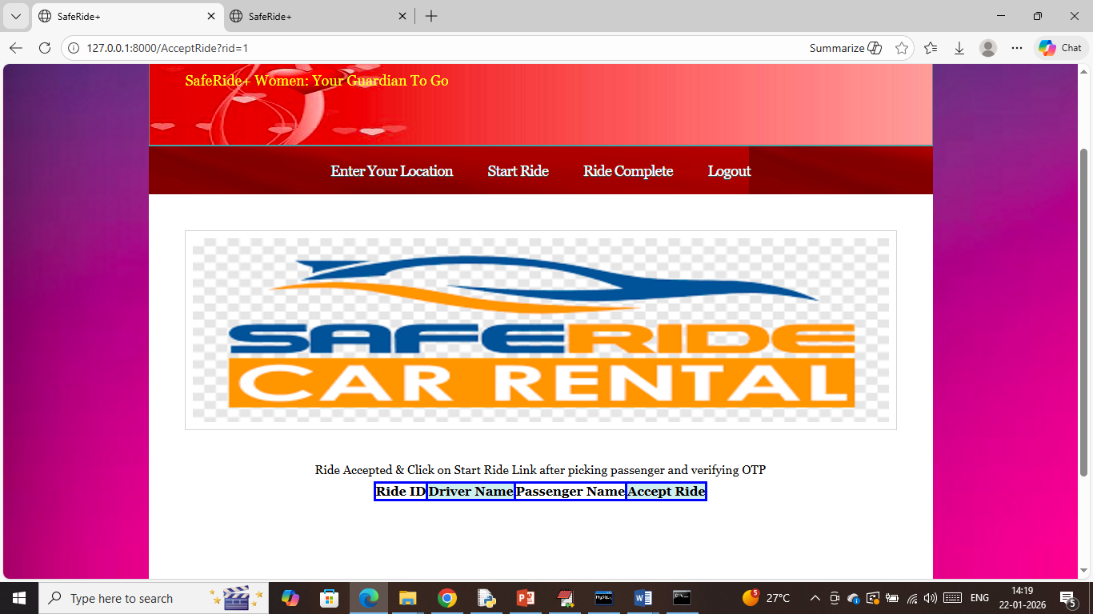
In above screen ride accepted and once after picking passenger driver will click on ‘Start Ride’ to start ride and then will get below page
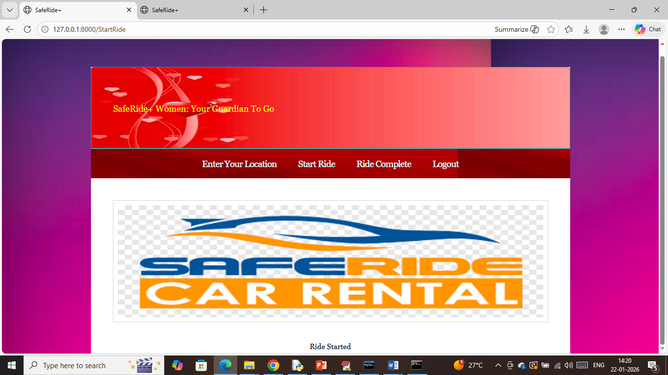
In above screen can see ‘Ride started’ and during ride if passenger feel any security risk then from his tab can click on ‘Raise Alert’ link to get below page
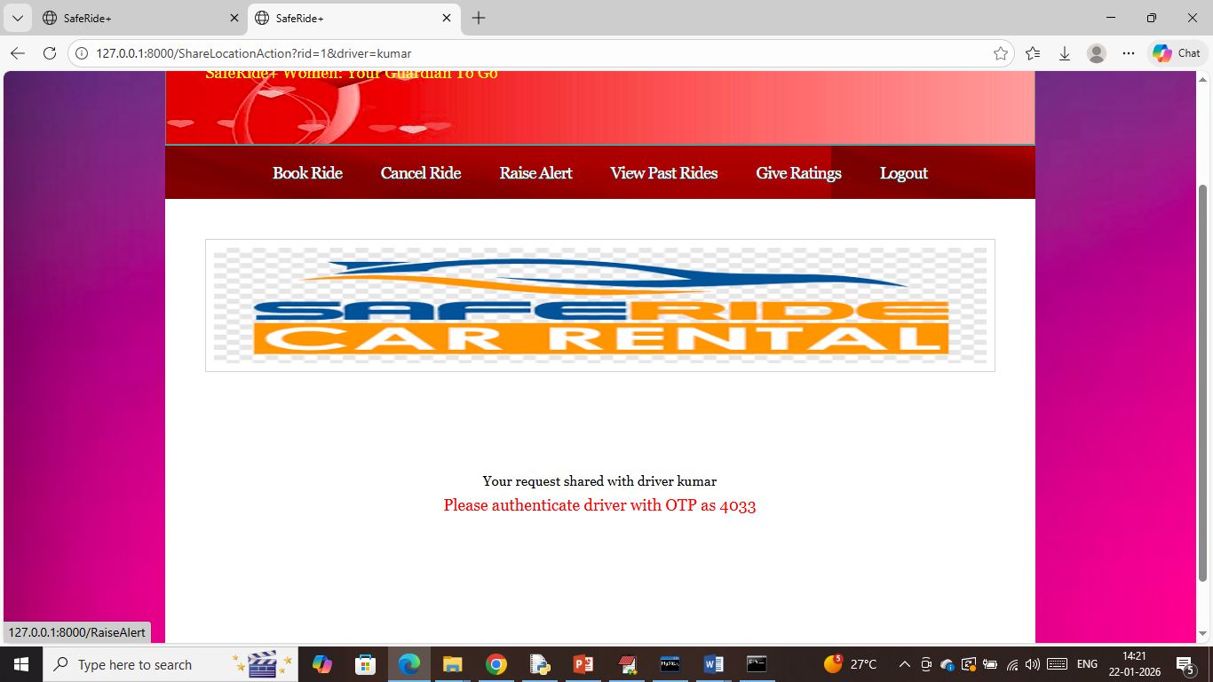
In above screen passenger can click on ‘Raise Alert’ link to send email to relatives and then will get below page
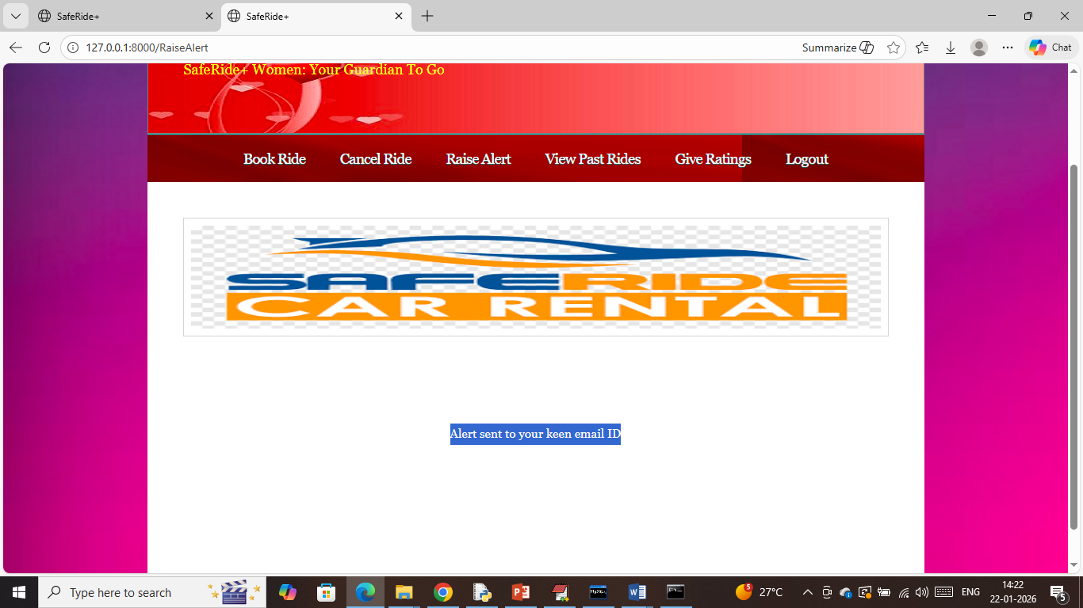
In above screen can see ‘Alert’ sent and in below screen can see received email
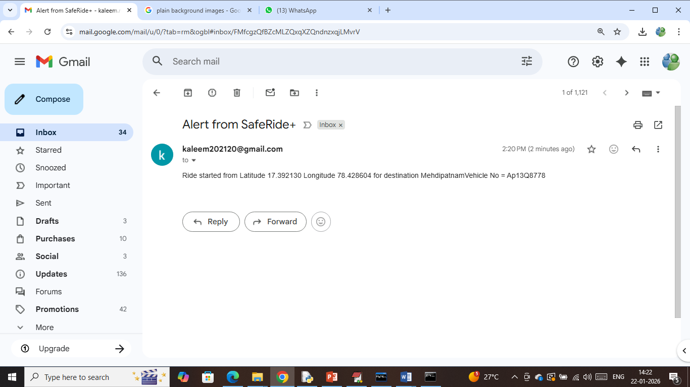
In above screen passenger relatives will get above alert and now go back to driver application to complete ride and accept payment
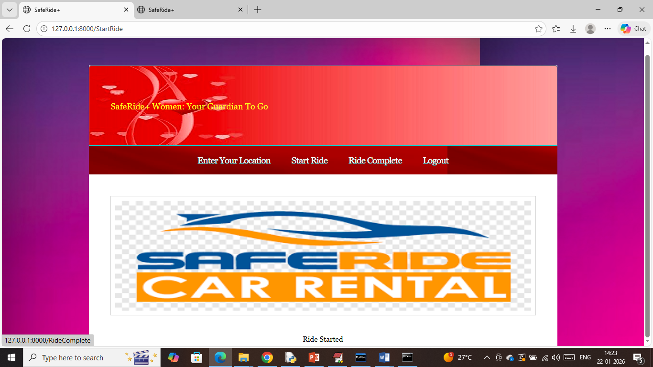
In above screen driver can click on ‘Ride Complete’ link to get below page
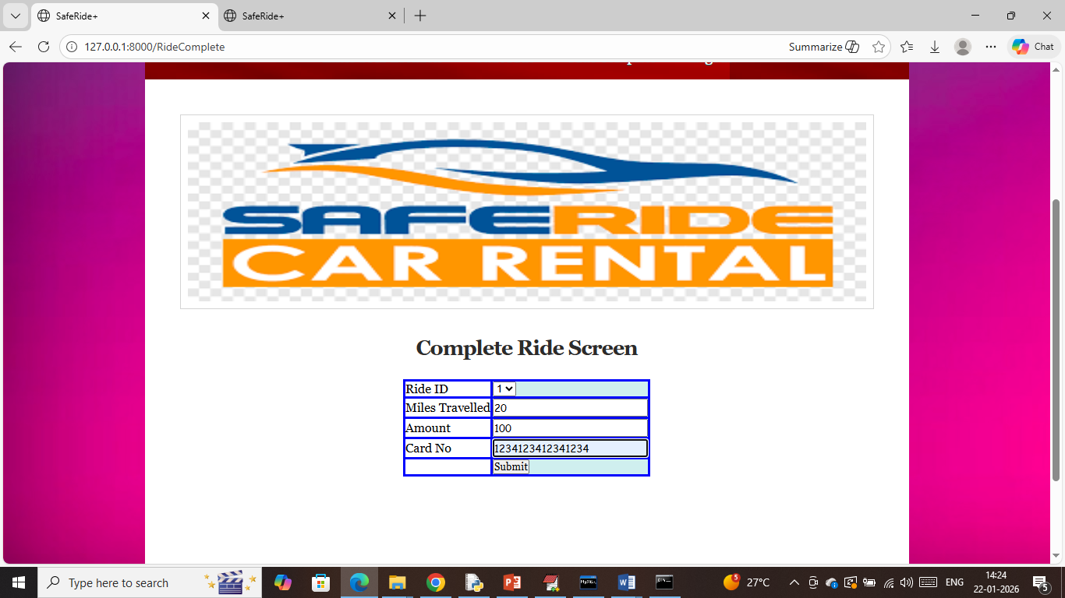
In above screen driver will select Ride id and accept dummy payment and then press button to get below page
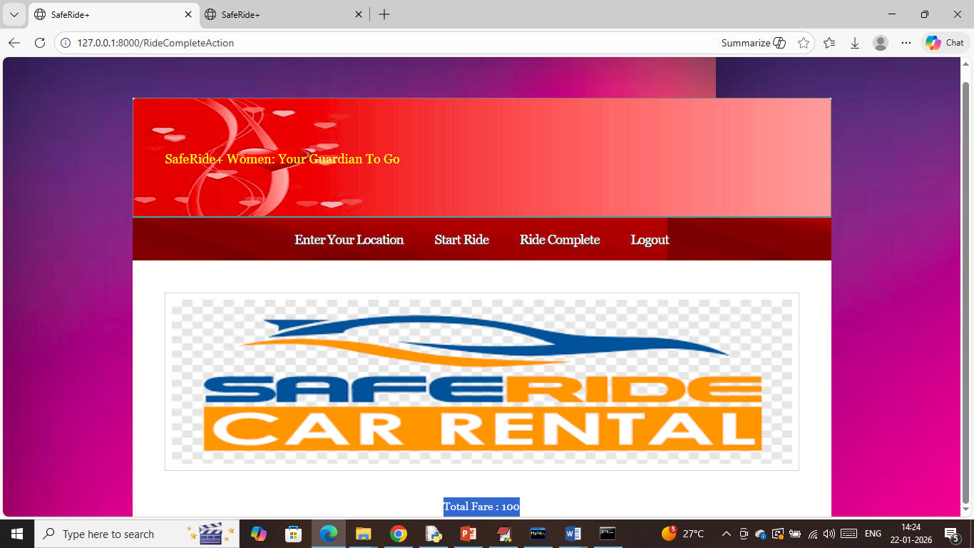
In above screen ride completed with total fare as 100 and now go back to “Passenger” screen to view other modules
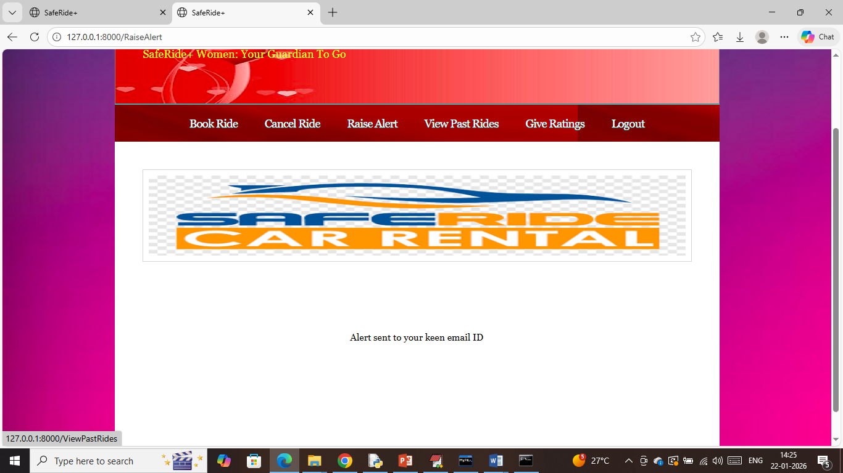
In above screen passenger can click on ‘View Past Rides’ link to get below page
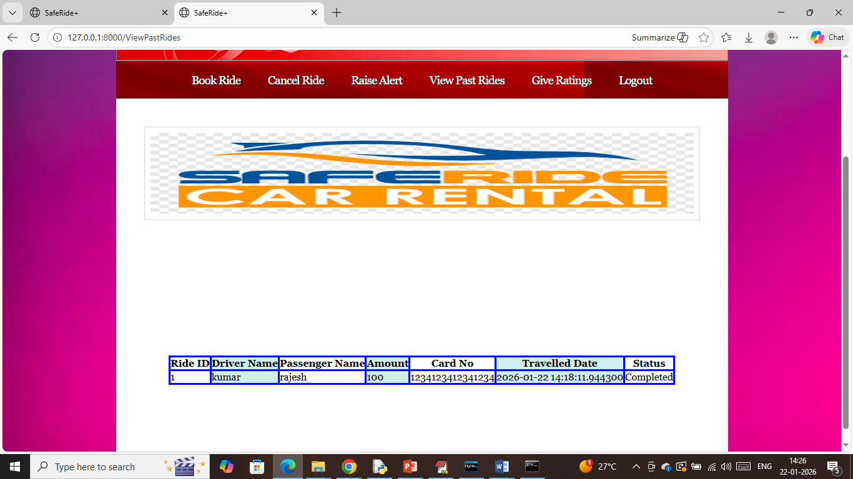
In above screen passenger can view all past rides and now click on ‘Give Ratings’ link to get below page
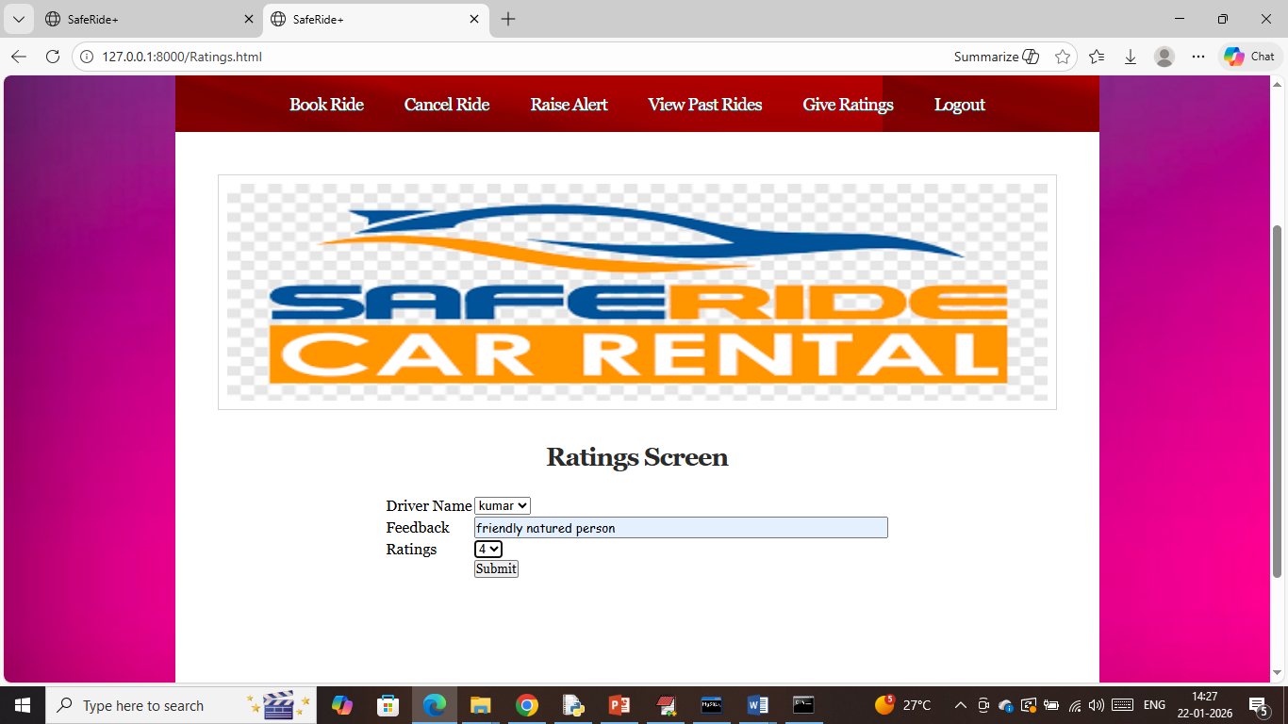
In above screen passenger will give feedback and ratings on selected driver and then press button to get below page
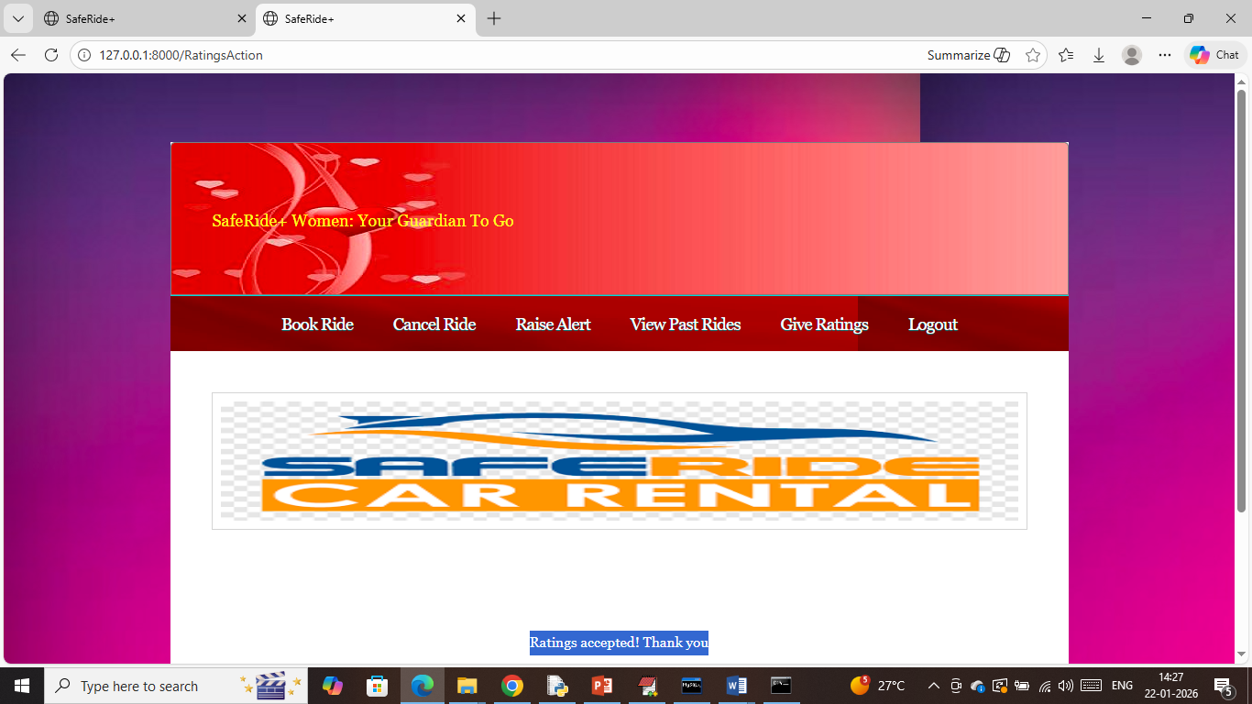
In above screen can see Ratings accepted
Upon booking and cancelled ride will get below page
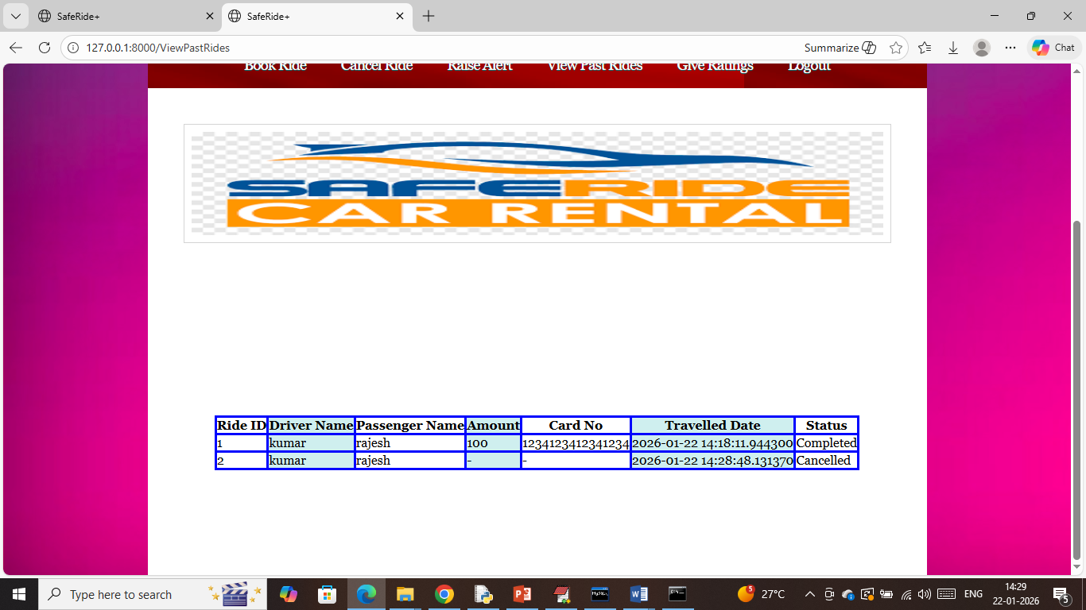
So by following above screens you can make any number of rides with emails alerts.

